In this lab we will create a New VPC and subnets under it. We will also discuss about default VPC

First got to GCP console and search for and click VPC

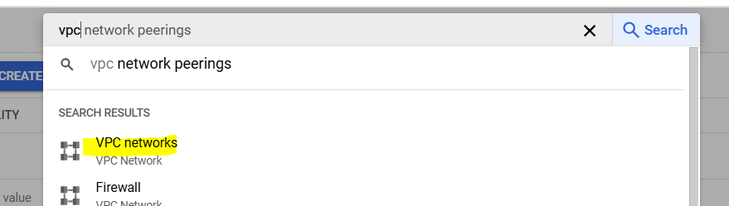

Here will see the default VPC already created. Open default VPC and go through its content

Default PVC have one default Subnet in every region

To create new VPC, click create new vpc network

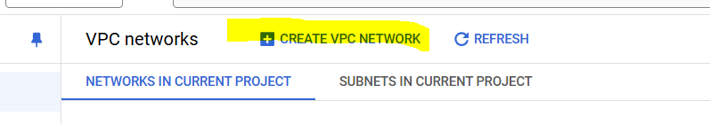

Give VPC a name

Keep subnet creation mode as Custom

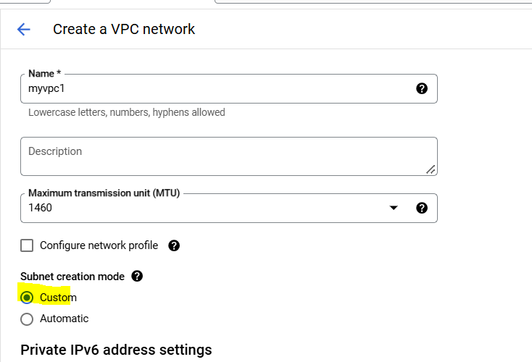

Fill Subnet details (for subnet calculation you can use <https://visualsubnetcalc.com/> )

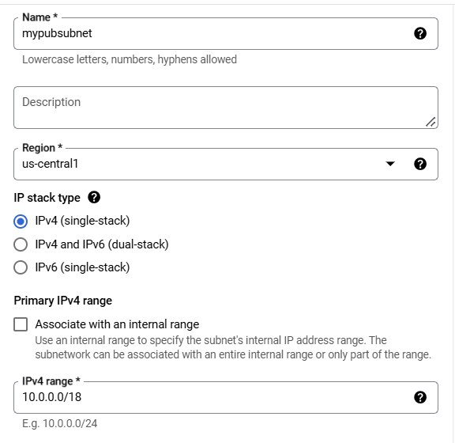

For public subnet, make “Private google Access” as OFF, and vice-versa

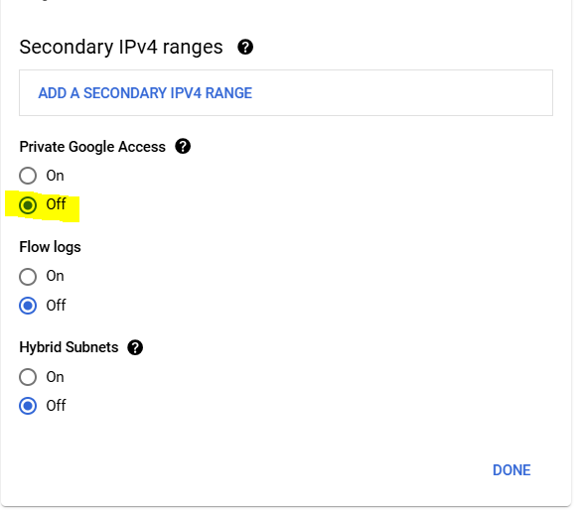

Keep all other settings default and click Create.

Once Subnet is created, go to the the VPC>Subnets and click Add subnet (Now we will create one private subnet)

Keep the region same as public subnet

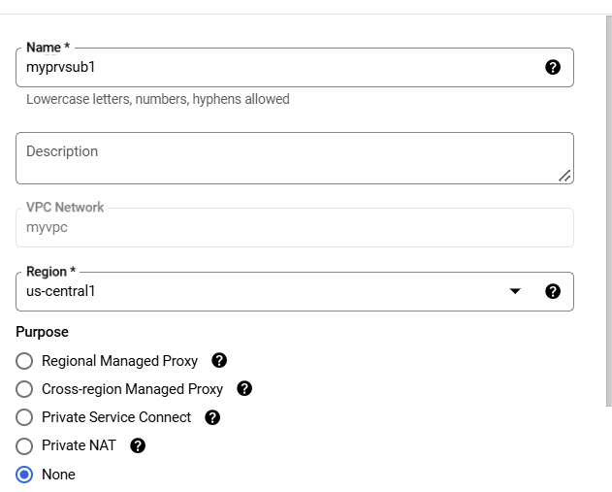

Give IP range and make “Private Google Access” as ON and Click ADD

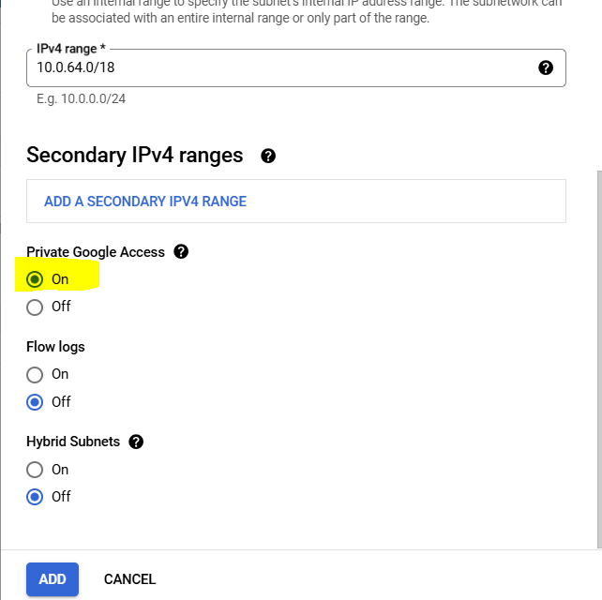

Once created, go to vpc and explore options, also explore subnet configurations